THE BIRTH AND DEATH OF CHAOTIC ATTRACTORS

V.Yu. Yevstignejev^{1, a}, M.V. Zakrzhevsky^{1, b}, I.T. Schukin^{2, c}
¹Institute of Mechanics, Riga Technical University
1 Kalku Str., Riga, LV-1658, Latvia
² Daugavpils branch of Riga Technical University
90 Smilshu Str., Daugavpils, LV-5410, Latvia
E-mail: ªvljevst@latnet.lv, ^{b}mzakr@latnet.lv, ^{c}igor@df.rtu.lv

Abstract
Behaviour of the nonlinear driven oscillators may be very complex and unexpected phenomena occur rather often in these systems: stable forced oscillations near unstable equilibrium position, rare attractors (RA). This paper devoted to the birth and death of rare chaotic attractors from fully unstable subharmonical isles in two-mass-chain-system with several equilibrium positions.

1. Introduction

The authors of this paper for many years have been studying nonlinear phenomena in one-mass driven oscillators, including symmetrical ones with two potential wells. Usual phenomena, as periodic and chaotic motion, and unusual, as stable forced oscillations near unstable equilibrium position, rare attractors (RA) [1] were found in such kind of systems.
Than, on example of bifurcation analysis of two-mass system it was shown, that all phenomena remain and there was found new one - fully unstable subharmonical isles [2, 3]. By changing system parameters, there appear rare stable periodic and chaotic regimes from these unstable isles.

2. Dynamical model

A system under consideration is chain system consisting of two bodies coupled by nonlinear stiffness with two equilibrium positions and linear damping and attached to base by linear stiffness and damping. External periodic force is applied to the body, attached to base (Fig. 1). Stiffness and damping forces are represented in Fig. 2. Also several additional characteristics, describing the system, are represented in this figure - potential wells of both stiffness and free damped oscillations of partial systems: 1). two rigidly coupled bodies attached to base by linear stiffness and damping; 2). second mass attached to fixed first body by nonlinear double-well stiffness and linear damping (Fig. 1).

Fig. 1. Physical model of the system

Corresponding equations of motion are

$\begin{aligned}\left\{m_{1}{\overset{¨}{x}}_{1}+b_{1}{\overset{˙}{x}}_{1}+c_{1}x_{1}−b_{2}\overset{˙}{x}−c_{\text{21}}x−c_{\text{22}}x^{3}=h1\text{cos}(ωt+φ_{0}) | \right.\end{aligned}$,

where x₁, x₂ – generalized coordinates (x = x₂ – x₁); m₁, m₂ – mass of oscillating bodies; b₁, b₂ – linear dissipation coefficients; c₁ – stiffness coefficient of the first linear elastic spring; c₂₁, c₂₂ - stiffness coefficient of the second nonlinear elastic spring; h1, ω, φ₀ – amplitude, frequency and phase of excitation.

3. Results

On the base of complete bifurcation groups method there is made bifurcation analysis at varying of initial conditions and parameter – excitation amplitude h1. Results of bifurcation analysis are demonstrated on Fig. 2.
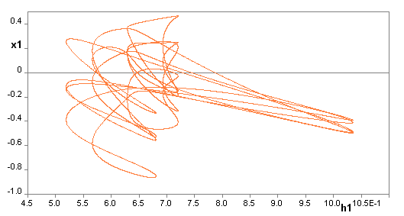
h1 = var.
two fully unstable – “desert”
2T twin isles
Р4
two fully unstable – “desert”
2T twin isles
h1
Р2
Р4
Р2
(a)
(b)

Р2

Р4
Р2

h1
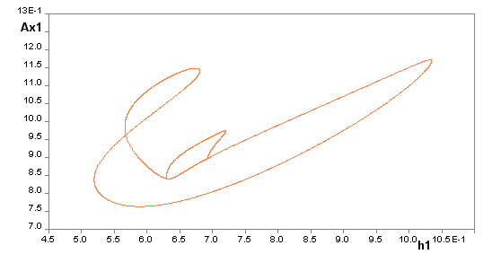

Fig. 2. Bifurcation groups of two completely unstable twins subharmonic isles 2T. Bifurcation diagrams for chained system with two degrees-of-freedom with three equilibrium positions of the second mass m₂ and linear dissipation at harmonic excitation (eq.). (a) coordinate x₁ of fixed point of the first mass vs excitation amplitude h1; (b) oscillation amplitude Ax1 of the first mass vs h1. Parameters: m₁ = m₂ = 1, b₁ = b₂ = 0.2, c₁ = 1, c₂₁ = -1, c₂₂ = 1, ω = 1, φ₀ = 0, k = 7, h1 = var.
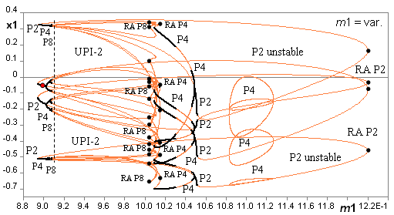

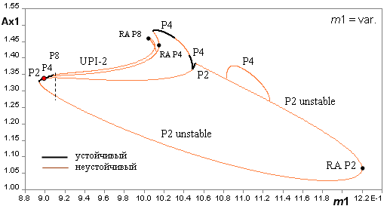
stable
unstable

Fig. 3. Appearance of stable regimes on the completely unstable subharmonic isles 2T (Fig. 2) – rare attractors at varying of the first mass m₁. Complete bifurcation diagrams for chained system with two degrees-of-freedom with three equilibrium positions of the second mass m₂ and linear dissipation at harmonic excitation (eq.). (a) coordinates x₁ of fixed point of the first mass vs m₁; (b) oscillation amplitude Ax1 of the first mass vs m₁. Parameters: m₂ = 1, b₁ = b₂ = 0.2, c₁ = 1, c₂₁ = -1, c₂₂ = 1, h1 = 1, ω = 1, φ₀ = 0, k = 7, m₁ = var.

Varying of other system parameters, mass of oscillating bodies, linear dissipation coefficients, particular stiffness coefficients or excitation frequency, leads to appearance of rare attractors on unstable branches of stable periodic regimes. As example, on Fig. 3, there are shown complete bifurcation diagrams of sub-harmonic isle 2T with rare attractors, regions with UPI and almost periodic oscillations at varying of parameter m₁. Rare attractor of tip type at m₁≈ 0.9 leads to appearance of unstable periodic infinitiums (UPI-2) and chaotic attractor (Fig. 4), but at m₁≈ 1.2 beyond rare attractor the region of almost periodic oscillations.

This work is supported by Latvian 2008 scientific grants R7329 and R7393.

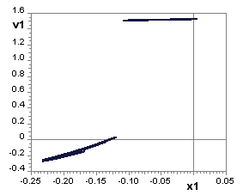
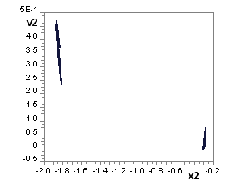
Chaos-2
Chaos-2
(a)

m₁ = 0.9105
m₁ = 0.9105

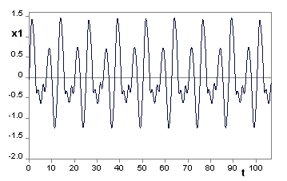
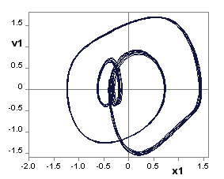
Chaos-2
(b)

Chaos-2
RA

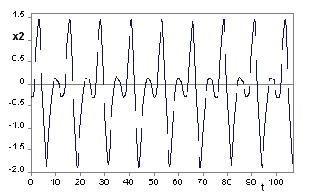
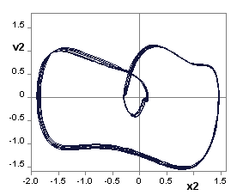
Chaos-2
Chaos-2
RA

Fig. 4. Rare chaotic attractors in chained system with two degrees-of-freedom with three equilibrium positions of the second mass m₂ and linear dissipation at harmonic excitation (eq.). (a) Poincaré map; (b) time histories and phase trajectories. Parameters: m₂ = 1, b₁ = b₂ = 0.2, c₁ = 1, c₂₁ = -1, c₂₂ = 1, h1 = 1, ω = 1, k = 7, m₁ = var.

References

[1] Zakrzhevsky М., Nonlinear Oscillatory and Vibro-Impact Systems: Rare Attractors. In: Proc. XIII Symposium on the Dynamics of Vibroimpact (Strongly Nonlinear) Systems, (Eds.: Astashev V.K. and Krupenin V.L.), Russia, Moscow-Zvenigorod, 2001, 156-162.
[2] Schukin I.T., Development of the methods and algorithms of simulation of nonlinear dynamics problems. Bifurcations, chaos and rare attractors, PhD Thesis, Riga – Daugavpils, 2005, 205 p. (in Russian)
[3] Yevstignejev V.Yu., Application of the Complete Bifurcation Groups Method for Analysis of Strongly Nonlinear Oscillators and Vibro-Impact Systems, PhD thesis, Riga, 2008, 146 p. (in Russian)

